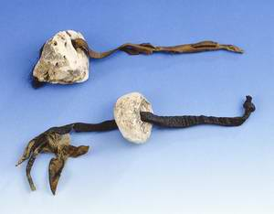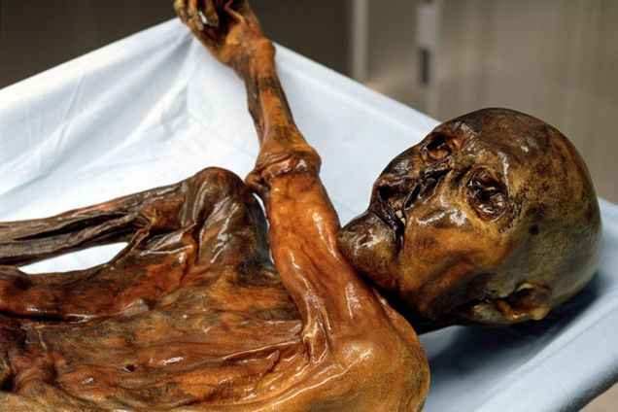

**Identify *four* artifacts Otzi carried on his trip.**

1.

2.

3.

4.

**FILL IN THE FOLLOWING**

OTZI’S AGE: __________

OTZI’S HEIGHT: _________

Otzi’s closest relatives are from this island:

S__________________

1.

2.

3.

3

4

2

1

#### List **four** cool facts about Otzi

### Facts about otzi

**If you could ask Otzi three questions, what would they be?**

otzi

# **Otzi the Iceman**

##### The World’s Only (Discovered) Stone Age Mummy

## **Using your imagination, draw a picture of Otzi as you envision him on his journey. Be detailed!**

###### In groups, invent the perfect Stone Age accessory that would be a must-have for Otzi to take on his journey. Draw a prototype in the space below.

**Read each theory on Otzi’s death and write a story detailing what you think happened during Otzi’s journey. What was his journey like? How do you think he died? Remember the 5 Ws (Who, What, When, Why, Where).**

## **What is *Your* Theory on Otzi’s Death?**

Sed venenatis, augue non varius tempus, metus nibh mollis erat, a tempus neque ipsum sit amet nisi. Donec elementum, justo eu pulvinar tincidunt, mauris nunc consectetuer mi, eu ornare augue ligula a nibh.

#### Consectetuer:

Pellentesque aliquet vulputate lacus. Nunc vitae felis at sem euismod pretium. Nam purus nisl, dignissim eu, facilisis eu, mattis consectetuer, arcu. Pellentesque habitant morbi tristique senectus et netus et malesuada fames ac turpis egestas.

#### Pellentesque: