Name:
Core:

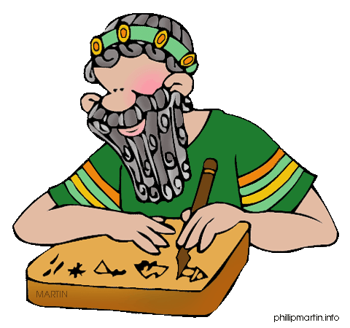

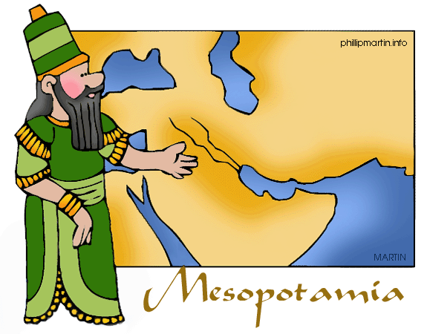MESOPOTAMIA WEBQUEST

Learning Target: I can describe the culture of ancient Mesopotamia including religion, social classes, jobs, art, and architecture and region.

1. On the home page they call Mesopotamia the “Cradle of Civilization”. Why?

2. Now click on the picture or the ‘Geography’ tab at the top. What is the meaning of
the word “Mesopotamia?”

3. What are the names of the two rivers?

4. How big of an area did ancient Mesopotamia cover?

5. What is the name of the geographic region in which Mesopotamia was located?

6. List the present-day countries that make up the location of the Fertile Crescent.

7. How did the Fertile Crescent get its nickname? (Give two examples)

Now click on the ‘History’ tab and go to Sumer.

8. Mesopotamia was first settled by the around BCE.

9. What were some other cities built in Sumer at that time? , ,
, . These are called - _.

10. They all shared the same , but they had their own rulers/kings,
, and .

11. King of Akkad attacked Sumer around BCE and created the world’s first . The Akkadian Empire didn’t last long due to fighting, invasions, and .

12. What group took over next?

13. Who was their King?

14. For what was he most famous?

15. How many laws were in Hammurabi’s Code?

16. What civilizations came after Babylon? Give a brief description of each.

a. b. c. d. e.

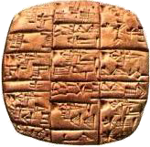Now click on the ‘Inventions’ tab. Watch the slideshow!

17. What was the first writing system invented by the Sumerians called?

18. Since it did not rain much, what system did Mesopotamians use to help grow their crops?

19. What did they use the pulley system for?
20. Name some other inventions and what they were used for. 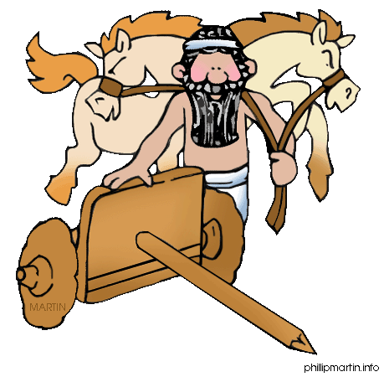

Now click on the ‘Daily Life’ tab.

21. List the social classes in Mesopotamia from highest to lowest.

22. From each of the following social classes, list one job that a person could have.

Upper: Lower: Slaves:

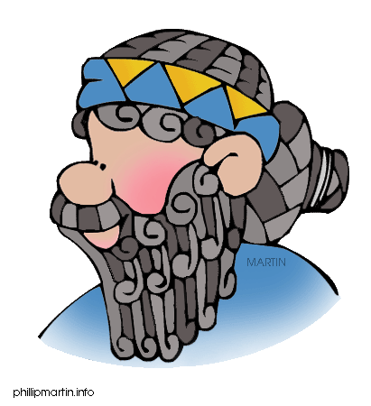23. Name two things priests were responsible for.

24. In ancient Mesopotamia, what did a man in the upper class look like?

25. Could Mesopotamians move up, or down, the social classes?

26. How did one become a slave in Mesopotamia?

27. True or False: Some ancient Mesopotamians lived in huts.

28. How many stories high was a typical Mesopotamian home?

29. Most houses were clustered around the .

30. What did Mesopotamians build their houses out of?

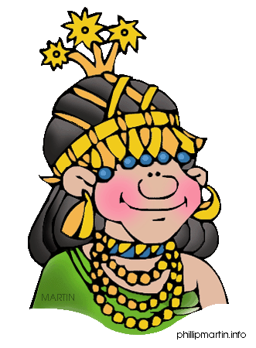‘Test Yourself’ tab

Play any of the three options. Have fun!

