Name: Gordon/Roman
Date:

Ancient Rome Webquest

What have the Romans done for us???? Apart from the sanitation, the medicine, education, public order, irrigation, roads, fresh water system, civil law codes, republican form of government, what have the Romans done for us? The legacy of the Roman Empire is extremely important. Over the centuries since the collapse of the Roman Empire, Roman ideas, literature, art and architecture have influenced many people around the world. Please complete the following webquest to gain an understanding of the importance of the Roman Empire and its influence.

Task #1: The Roman Gladiator

Roman Webquest……
The ancient Romans are often seen as bringing civilization to the western world, but they regarded the slaying of gladiators as a normal form of entertainment.
1. List four reasons why you wouldn’t want to be a Roman prisoner. What
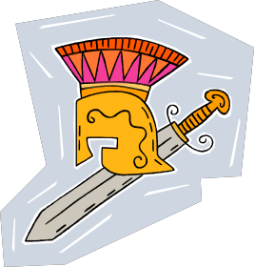would be your fate?

1.

2.

3.

4.

2. Describe how you were bought and sold. Include information on the

sick.

3. List three things that happen if a slave’s owner sends him to a
ludus gladitorius.

1.

2.

3.

4. Name 5 types of gladiators and what were there functions,
Type | Function
1.
2.
3.
4.
5.

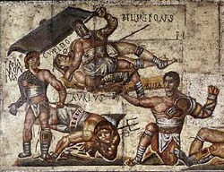5. What other types of entertainment for the crowd took place before the actual fight took place?

6. What could a Gladiator do to prevent his death?

7. Explain the following:

a. Finished off -

b. Dragged away

c. Cleaners

d. Describe the Coliseum of Rome. Include when and why it was built, and what it was used for other than gladiatorial combat.

e. How were people seated in the Coliseum?

f. How did spectators sometimes become part of the show?

Task 2: Project Runway: Roman Fashion
List three facts about Roman fashion
Men
Women
Child ren

Describe the Bulla and its purpose.
Task #3: | Roman Religion: Complete the | following | chart | with
names of | both Greek and Roman gods.

Roman name | Characteristics | Greek name
King of all the
gods; hurled
thunderbolts
 | Queen of the gods and protector of marriage
 | God for the sea; Zeus’ bro
 | God of the underworld—the world of the dead
 | Goddess of wisdom and patron of Athens

The sharing of the same gods is and example of
or the spread of culture
and ideas.

Imported Gods Who were three “imported” gods to Rome?

1.
2.
3.

Christianity
Which emperor converted the Roman Empire to Christianity?

When? .

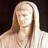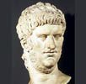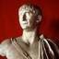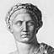Task # 4: FAMOUS ROMAN EMPERORS Directions: Use the link below to research the most important Roman Emperors. For each of the emperors listed below, discuss their positive and/or negative impact on the Roman Empire. The chart should be completed in note form.

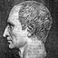FAMOUS ROMAN EMPERORS

Emperor | Positive/Negative Impact on Roman Empire
Julius  Caesar | 1.  2.
Augustus | 1.  2.
Nero | 1.  2.
Trajan | 1.  2.
Constantine | 1.  2.
Justinian | 1.  2.

Task #5 THE ROMAN EMPIRE AND ITS VAST NETWORK OF ROADS:

1. Name several lands that were part of the Roman Empire in
12 C.E.

2. What additional lands did the Romans gain control of by
150 C.E.

3. (a) How did the size of the Roman Empire change between
150 C.E. and 500 C.E.?

(b) What do you think caused the size of the Roman
Empire to change?

4. Which modern day countries did the Roman Empire comprise of? Provide five specific examples.

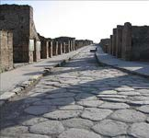5. Why did the Roman army need a more advanced Road system?

6.Use Source C for reference. Discuss how Roman roads were built.

7.Use Source D | for reference. | Why were Roman roads safe to
travel large | distances?

8.Based on this map, why was important for the Roman Empire to build a vast network of roads?

The Twelve Tables of Roman Law

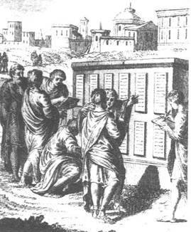The Twelve Tables were collectively a piece of legislation written by ten consuls as a basis of law for the young Roman Republic. The important basic principle of a written legal code for
Roman law was established, and justice was no
longer based solely on the interpretation of judges. These laws formed an important part of the foundation of all subsequent Western civil and criminal law.

Answer the following questions on the Twelve
Tables by clicking on the link provided.

1.By about the 6th century B.C., what were the two basic social classes in the Roman Republic?

▪

▪

2.Which social class had the power to make the laws?

3.Read the Laws of the Twelve Tables

Which laws 3 laws are still applicable for today’s society? EXPLAIN WHY.

Roman Architecture

The Architecture of Ancient Rome borrowed much of its style and technique from classical Greek architecture. The blending of Greek, as well as other architectural styles worked to create
a new architectural Roman style. Roman and Greek architecture is
often referred to as classical architecture.

Answer the following using the link provided.

1.From whom did the Romans learn most of their architectural techniques?

2.What materials did the Romans use to build their structures?

The Pantheon

3.What was the Pantheon used for?

4.Describe the architectural style of the Pantheon:

The Aqueducts

5.What were the Roman aqueducts used for?

6.What were some challenges engineers faced in designing aqueducts?

